
ENGINE P21 – le mans

FIRST START

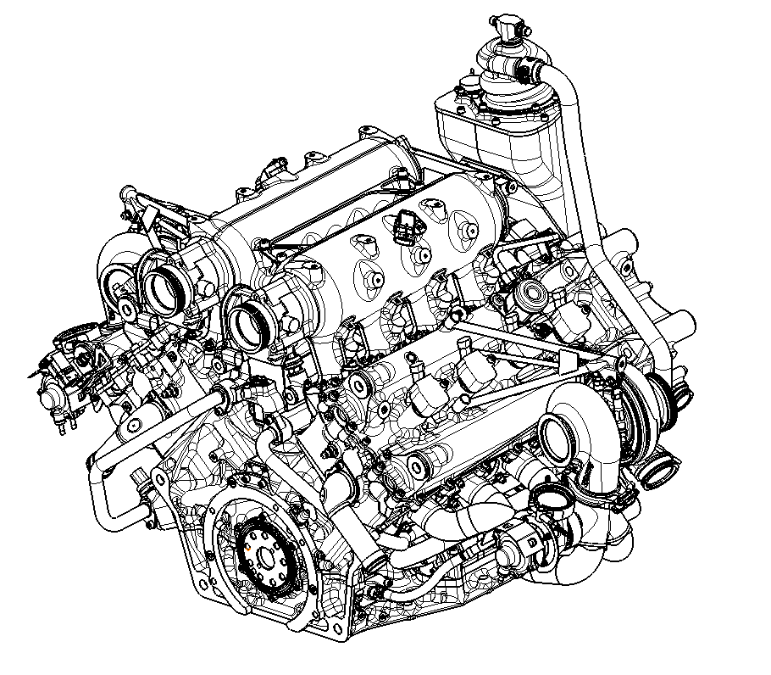

ENGINE DATA LOOK UP

Pressure sensor
Description |  | ID | ECU Name | Nominal Values (Min-Max) | Alarm Low | Alarm High | Default values
 | Engine Oil Pressure | 9 | poil | 1.5 bar (at 1500) – 6.5 bar (at 5000) (Abs) | See annexe Map | - | 5.55
 | Crank Case Pressure | 11 | pcrank | 600 mbar – 850 mbar (absolute) | - | > 1050 mbar | 888
 | Water Pressure Tank | 17 | pwat | - bar – 2.5 bar (relative) | Pwat < 0.5bar | Pwat > 3.50 bar | 1.11
 | Intake manifold pressure | 5 | p22-p22_2 | 300 mbar – 2500 mbar (absolute) | - | P22 > 2500 mbar | 2222
 | Barometric Pressure | 16 | pamb | 950 mbar – 1050 mbar (absolute) | Pbaro < 750 mbar | PBaro > 1100 mbar | 1013
 | Fuel Rail Pressure | 2 | prail-prail2 | 150 bar (relative) | Prail < 30 bar | Prail > 200 bar | 111
 | Low Fuel Pressure | 1 | pfuel-pfuel2 | 7 bar (relative) | PFuel < 4 bar | PFuel > 8 bar | 6.66
Description |  | ID | ECU Name | Nominal Values (Min-Max) | Critical values Max (Alarm High) | Default values
 | Engine Oil Temperature | 9 | toil | 100 - 125 °C | >130 °C | 105
 | Engine Water Temperature | 8 | tmot-tmot2 | 90 -110°C | >115°C | 88
 | Intake manifold Temperature | 4 | tint-tint2 | 10 - 40°C | >70°C | 55
 | Barometric Temperature | 15 | tamb | 10 - 40°C | - | 20
 | Fuel Rail Temperature | 2 | trail_pod-trail2_pod | 10 - 60°C | >°C TBC | 55
 | Low Fuel Temperature | 1 | tfuel | 10 - 60°C | >80°C | 55
 | Exhaust Gas Temperature | 13 | texh-texh2 | 500 - 850°C | >900°C | 888

Temperature sensor

Other sensor
Description | ID | ECU Name | Nominal Values (Min-Max) | Critical values (Min-Max) | Default values
RPM | 4 | nmot | 2000 – 7500 rpm | >8000 rpm | -
Lambda Sensor | 12 | Lam1-Lam2 | 0.80 – 1.05 | Lam<0.8 Lam>1.05 (2sec) | 1.23
Turbo speed | 7 | nturbo-nturbo1 | 25 000 – 185 000 rpm | >180 000 rpm | -
Oil level | 14 | Oil_level | 2.50-6.50 ltrs | < 2.5l | 3.33

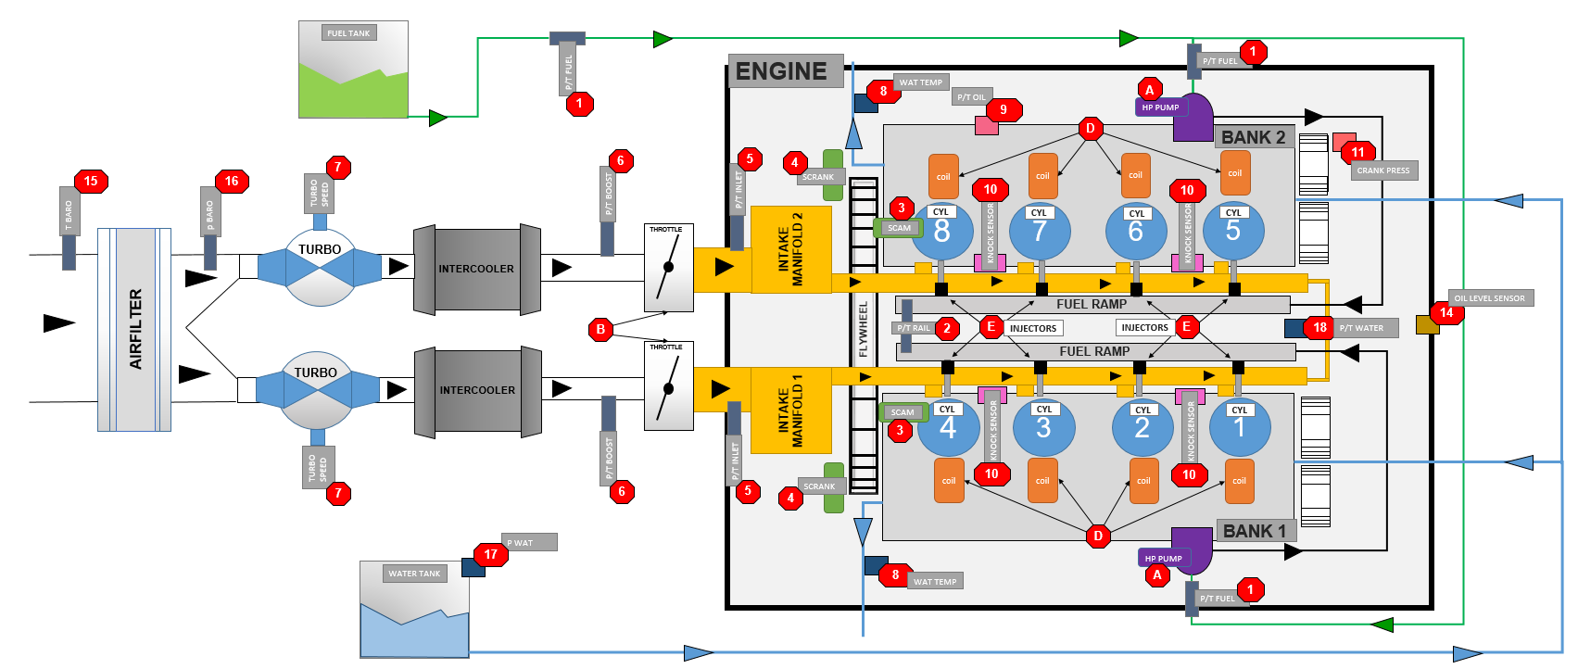
ENGINE DRAWING :

GEARBOX

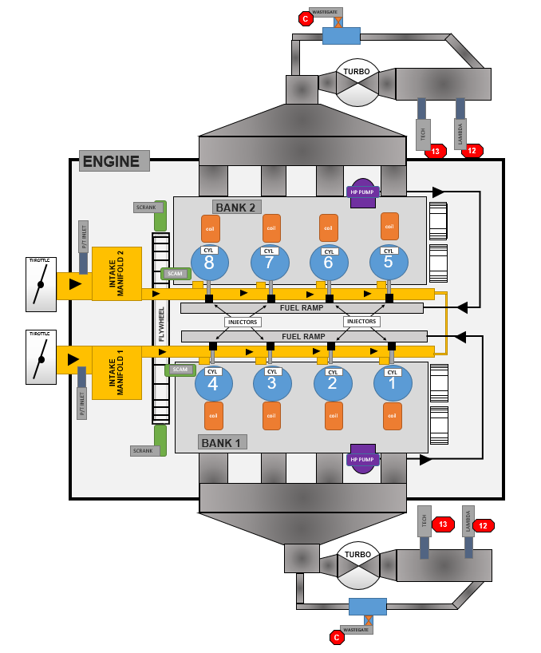

RECOMANDATION BEFORE STARTING :

- Rise the oil pressure up to 3.0 bar (abs) at toil : 25 °C by cranking before cold start – should be 0.5 bar when the oil is warm.
- Increase Water tank pressure to 1.5 (abs) before starting.
- The by-pass on the oil exchanger is currently fully open, that means you will warm up quicker the oil through the cooling system.
- While the engine is running check the sensors below :
- Oil pressure
- P Crank
- OIl temperature
- Lambda
- Water cooling temperature (stop the engine when @ 95°C if on the stands)
- Water tank pressure
- P fuel
- P Rail
MANDATORY :
- Pedale auto-calibration
- Throttles auto-calibration

ADDITIONALY
DIAGNOSIS :

- In a way to check the alarm on the data it could be great to have a bit mask into each bits represent an alarm as below :

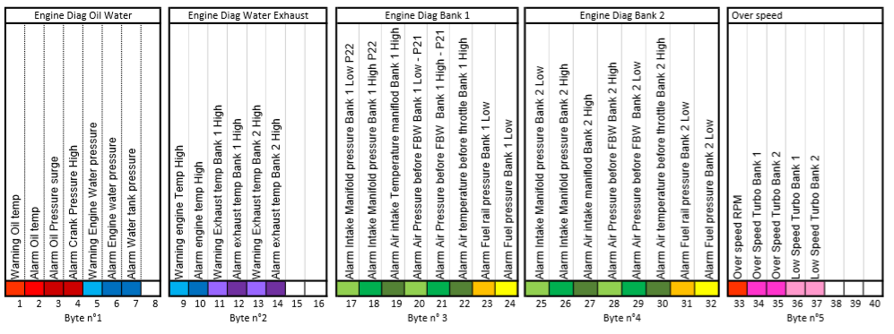

Recovery strategy

Water engine Temp Faillure :
If the water température sensor has a faillure it could be interesting to have a Water temp model like TMot Rec= TOil - 10°

Engine Oil Temp Faillure :
TOil Rec : TMot + 10

P22 pressure faillure :
Option are possible :
- Used the P22 from the other bank
- Used the P21 with an ATH Normalisation flow map

ANNEXE

3D model for engine oil pressure alarm (1 = alarm on) , time validation = 0.5 sec
 | 2000 | 3000 | 3500 | 4000 | 4500 | 5000 | 5500 | 6000 | 6500 | 7000 | 7500 | RPM
1.50 | 1 | 1 | 1 | 1 | 1 | 1 | 1 | 1 | 1 | 1 | 1
2.50 | 0 | 1 | 1 | 1 | 1 | 1 | 1 | 1 | 1 | 1 | 1
3.00 | 0 | 0 | 1 | 1 | 1 | 1 | 1 | 1 | 1 | 1 | 1
3.25 | 0 | 0 | 0 | 1 | 1 | 1 | 1 | 1 | 1 | 1 | 1
3.50 | 0 | 0 | 0 | 0 | 1 | 1 | 1 | 1 | 1 | 1 | 1
3.75 | 0 | 0 | 0 | 0 | 0 | 1 | 1 | 1 | 1 | 1 | 1
4.00 | 0 | 0 | 0 | 0 | 0 | 0 | 1 | 1 | 1 | 1 | 1
4.25 | 0 | 0 | 0 | 0 | 0 | 0 | 0 | 1 | 1 | 1 | 1
4.50 | 0 | 0 | 0 | 0 | 0 | 0 | 0 | 0 | 1 | 1 | 1
4.75 | 0 | 0 | 0 | 0 | 0 | 0 | 0 | 0 | 0 | 1 | 1
5.00 | 0 | 0 | 0 | 0 | 0 | 0 | 0 | 0 | 0 | 0 | 1
Poil

